Mapping the industrial base for the new energy economy

Ishana Ratan, Benjamin E. Bagozzi, Jonas Goldman, Becky Han, Tim Sahay, and Bentley B. Allan

Abstract: Countries are designing green industrial policies to upgrade their economies and position their firms in global value chains. If successful, these strategies could generate cost declines, locking in decarbonization pathways with new energy technologies. However, there are two central risks. First, countries could make investments in sectors where they are unlikely to be competitive. Second, poor quality information about economic opportunities could lead several countries to compete in a small number of technologies. Countries must diversify investments and compete in their areas of strength, but this requires granular tools to map capabilities and opportunities. In this paper, we identify the priority sectors for investment across countries. We present a machine learning model that predicts country competitiveness across 10 clean energy technologies. The model also specifies the parts of countries' industrial base that drive competitiveness in each area and demonstrates that each country has a unique profile that shapes its competitiveness. The model enables countries to identify both existing strengths and provides pathways for building future capabilities in specific industrial areas.

Keywords: industrial policy; industrial base; green comparative advantage; exports; machine learning; global value chains

Summary Paragraph
Countries are increasingly leveraging green industrial policies to both pursue decarbonization and improve the position of domestic industry in global value chains. Yet there is deep uncertainty about which technologies make for good investments, and poorly targeted strategies risk costly investment in crowded sectors. Here we predict country competitiveness across ten clean energy technologies using a machine-learning model built on granular measures of industrial capabilities. The results reveal that competitiveness depends upon a core set of industrial capabilities: electronics, machinery, mining and metals, industrial materials, and chemicals. Moreover, each technology has a unique profile of capabilities that predict competitiveness. This work advances the study of green industrial policy by providing a clear profile of capabilities necessary for competition in key green technologies, and a strategy for countries to identify their strengths and weaknesses across the supply chain. As countries implement green industrial policies, it will be critical that states avoid over-investments in sectors where they lack capabilities and play to their strengths in green value chains.

Introduction
Countries all over the world are designing green industrial policies to upgrade their economies and position their firms in global value chains.^{1–5} The success of China’s industrial strategy for wind, solar, and batteries has spurred action in both developing and developed countries. Focused investment and coordination in China and elsewhere drove down the cost of these technologies such that they are now competitive with conventional energy incumbents.⁶ There is now intensifying competition in a range of technology verticals including heat pumps, electrolyzers, permanent magnets, biofuels, nuclear, geothermal, and transmission equipment. If successful, these strategies could generate cost declines, locking in decarbonization pathways with new energy technologies.
However, there are two central risks. First, countries could make wasteful investments in sectors where they are unlikely to be competitive.⁷ Second, poor quality information about the industrial base required to produce a technology and global landscape of competition will lead many countries to compete in a small number of technologies. For example, in 2020 and 2021, many countries announced hydrogen or solar manufacturing strategies.[IEA] Such strategic concentration can create real problems for developing countries, as overinvestment in coffee and other commodities led to price crashes in the 1960s.⁸ To mitigate these risks, countries need rigorous tools to help them explore the whole opportunity space, identify competitive strengths, and design strategic interventions to build the necessary capabilities.
In this paper, we present results from a machine learning model that predicts country competitiveness across 10 clean energy technologies. The model supports countries’ strategic focus by quantifying their current position and highlighting strengths and weaknesses in the underlying industrial base needed to compete. A key finding of our models is that five sets of capabilities are critical for predicting country competitiveness: electronics, machinery, mining and metals, industrial materials, and chemicals. Moreover, each technology has a unique profile corresponding to the kind of industrial base needed to be competitive. For example, solar competitiveness is driven primarily by strength in metals (e.g. mounting structures for solar arrays) and chemicals, while battery competitiveness is driven by strength in machinery and chemicals. Thus, the model suggests that countries can improve their competitiveness in solar or battery production by investing in these capabilities. By providing this analysis across 10 clean energy verticals, the model maps the whole opportunity space, enabling countries to diversify investment, and suggests areas for targeted investment that can form the basis for smart interventions in a range of clean technology sectors.
Our approach is grounded in an interdisciplinary tradition in innovation and industrial policy studies which argues that knowledge underlies industrial capabilities, which form the basis of competitive manufacturing ecosystems.^{9–11} Since the knowledge necessary to design and manufacture advanced technologies is formed through dense interactions between government agencies, research labs, and production facilities, capabilities tend to cluster regionally and nationally.^{12,13}[+gertler and lundvall] As Nahm has shown, in highly complex value chains, national and regional comparative advantages are integrated in collaborative industries with a global division of labor.¹⁴
The critical role of knowledge formation means that comparative advantage can be constructed over time by smart industrial strategy.[Amsden 1989; Lin and Chang 2009; Rodrick 2014] As the case of China shows, countries can develop economically by investing in research and development, technology transfer, and process innovation through manufacturing [Naughton, Lewis, Nahm]. But critically, comparative advantage is not infinitely elastic. Especially in the short-term, industrial policy is likely to be most successful in specific regions that have “absorptive capacity”: the knowledge networks necessary to translate production into innovation and enduring advantage.[Yin et al 2021]
Building on these insights, recent research has argued that countries should invest in upstream capabilities and products that are adjacent to existing capabilities.[Liu, Lane, Hidalgo and Hausmann] Korea, for example, transformed itself into a modern manufacturing and chemicals powerhouse by strongly subsidizing upstream metal and chemical production and allowing the benefits to flow downstream. The seminal work of Hausmann and Hidalgo on economic complexity argues that countries should seek to develop capabilities in products that are related or adjacent in the product space to their current exports ¹⁵. At the core of their approach is the idea that economies possess knowledge and skills that are not easy to acquire. Rosenow and Mealy, building on earlier work by Mealy and coauthors, create indices to assess countries’ decarbonization technology strengths and opportunities ^{16,17}. They follow Hausmann and Hidalgo in arguing that countries have opportunities in areas where their current capabilities align with their current revealed comparative advantage profile. We follow this work by building our model on the insight that export competitiveness is a strong proxy for underlying capabilities.
We build on this work in three ways. First, we offer a broader and more comprehensive view of the opportunity space. Whereas Rosenow and Mealy analyse solar, wind, and electric vehicles (EVs), we cover those plus heat pumps, transmission equipment, electrolyzers, geothermal, nuclear, biofuels, and magnets. Second, our approach is more inductive than existing models. We use a random forest classification model to predict export competitiveness in the final product for each technology vertical. The strength of a random forest model is that it is broadly inductive and does not require us to make strong assumptions about what will predict competitiveness in final product. Third, to gain a better understanding of the role of the upstream industrial base in shaping competitiveness, we include not just coexports for products in the supply chain, but products in what we call the process chain—the machines used in manufacturing processes. Our model, then, uses three sets of independent variables: revealed comparative advantage in products in the supply and process chains for each technology, the co-exports for these products, and a slate of country characteristics (including GDP, manufacturing as a percentage of GDP, etc.).
In short, green industrial strategy is an essential tool to drive climate action, but to do it well countries need granular tools to map capabilities and opportunities. Knowledge networks can be forged locally and integrated into the global technology frontier through disciplined supports. But these industrial strategies are more likely to be successful if they build upon existing strengths while charting pathways into new areas.
The model presented here supports and advances this by providing an open-ended and strategic lens on country opportunities. The random forest model allows us to identify the most important predictors of competitiveness, which can inform the identification of upstream investment targets, allowing countries to build their industrial base in specific ways.

Analysis
We use a random forest classification model to evaluate the determinants of competitiveness across our 10 clean technologies. We provide an overview of the key independent and dependent variables before turning to model parameters and results.
We draw upon BACI trade data to calculate our key export measures ²¹. The methods section provides an in-depth discussion of variable construction and selection.
The dependent variable is a binary indicator of 1-0 if a country has revealed comparative advantage (RCA) over one, meaning that it exports more than its “fair share” of a product. Most countries do not have a high RCA in each product, so a binary dependent variable is appropriate as it somewhat mitigates issues of class imbalance. Table 1 reports the HS code we use for the dependent variable, the means of RCA in each dependent variable, and percent of nonzero values for our binary dependent variable. For entries with multiple HS codes listed, a composite dependent variable was constructed by adding together the values for each code and calculating RCA of the composite.
Table 1. Dependent variables summary by technology.
Technology | HS Code | Mean RCA | Percent RCA > 1
Solar | 854140: Electrical apparatus; photosensitive, including photovoltaic cells, whether or not assembled in modules or made up into panels, light-emitting diodes (LED) (17)  854142: Electrical apparatus; photosensitive semiconductor devices, photovoltaic cells not assembled in modules or made up into panels (22)  854143: Electrical apparatus; photosensitive semiconductor devices, photovoltaic cells assembled in modules or made up into panels (22) | 0.26 | 5.87
Wind | 850231: Electric generating sets; wind-powered, (excluding those with spark-ignition or compression-ignition internal combustion piston engines) (22) | 0.56 | 4.85
Batteries | 850760: Electric accumulators; lithium-ion, including separators, whether or not rectangular (including square) (22)  850780: Electric accumulators; other than lead-acid, nickel-cadmium, nickel-metal hydride and lithium-ion, including separators, whether or not rectangular (including square) (22) | 0.22 | 4.92
Electrolyzers | 854330: Electrical machines and apparatus; for electroplating, electrolysis or electrophoresis (22) | 0.32 | 7.90
Heat Pumps | 841861: Heat pumps; other than air conditioning machines of heading no. 8415 (22), 841581: Air conditioning machines; containing a motor driven fan, other than window or wall types, incorporating a refrigerating unit and a valve for reversal of the cooling/heat cycle (reversible heat pumps) (22) | 0.44 | 14.01
Permanent Magnets | 850511: Magnets; permanent magnets and articles intended to become permanent magnets after magnetisation, of metal (22), 850519: Magnets; permanent magnets and articles intended to become permanent magnets after magnetisation, other than of metal (22) | 0.27 | 5.10
Nuclear | 840110: Nuclear reactors (22), 840140: Nuclear reactors; parts thereof (22) | 0.30 | 6.27
Biofuels | 220710: Undenatured ethyl alcohol; of an alcoholic strength by volume of 80% vol. or higher (22), 220720: Ethyl alcohol and other spirits; denatured, of any strength (22) | 2.15 | 21.38
Geothermal | 841950: Heat exchange units; not used for domestic purposes (22) | 0.40 | 13.09
Transmission | 850431: Electrical transformers; n.e.c. in item no. 8504.2, having a power handling capacity not exceeding 1kVA (22), 850432: Transformers; n.e.c. in item no. 8504.2, having a power handling capacity exceeding 1kVA but not exceeding 16kVA (22), 850433: Transformers; n.e.c. in item no. 8504.2, having a power handling capacity exceeding 16kVA but not exceeding 500kVA (22), 850434: Transformers; n.e.c. in item no. 8504.2, having a power handling capacity exceeding 500kVA (22) | 0.69 | 20.80

To construct our independent variables, we calculate countries’ revealed comparative advantage in products along the supply chain, following Rosenow and Mealy. In a critical difference between our model and others, we also include RCA scores in what we call the process chain. This includes the technologies needed to make each component in the supply chain. For example, in batteries we include the HS code for cathode active material, the copper foil, and the mixers used to transform cathode active material into a slurry which is then sprayed on the foil. This enables our model to capture not only exports in the supply chain, but also the capital goods needed to produce the technologies. Manufacture of capital goods, requires a specific and sometimes more complicated set of industrial capabilities not included in the production of products themselves. By including the capabilities necessary to manufacture process equipment itself, our approach widens and more accurately captures the determinants of comparative advantage compared to previous research ^{15,17}. We provide a detailed account of our supply chain mapping process in Supplemental Information Section SI.1-SI.10. We calculate the co-export probability of these products include all additional products with a minimum co-export probability greater than 0.55, following Hausman and Hidalgo. We summarize the number of supply chain components and proximate products by technology in Extended Data Table 1.

Results
The model presents three kinds of results. First, a ranking of all countries by predictive competitiveness across the 10 technologies. Second, a list of the products driving competitiveness in each technology. Third, a mapping of the core capabilities, what we call the industrial base, needed to be competitive in each technology. The three pieces fit together to give a granular view of the opportunities that countries have in clean technology value chains. Whereas previous work offers a status quo view of the opportunity space, our model enables countries to take a strategic perspective. By identifying the core industrial capabilities needed to compete in each technology, the results point to specific areas that countries can invest in to improve their competitiveness.
First, the model predicts competitiveness, defined as the likelihood that any given country has revealed comparative advantage in a product, which indicates export specialization. Our model predicts this for all countries with a population over 1 million people, resulting in a universe of 155 countries. Figure 1 visualizes predicted competitiveness for the top 20 countries as of 2023 in 9 of the 10 technologies in this study (the plot for electrolyzers can be found in Supplemental Information Section SI. 21-27).

Figure 1. Top 20 countries by predicted competitiveness across 9 clean energy technologies.
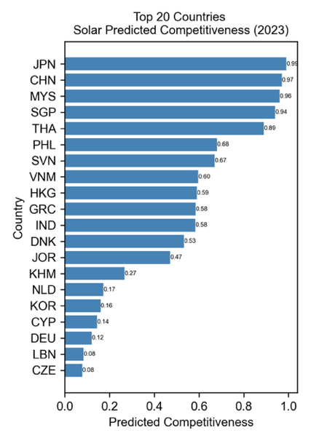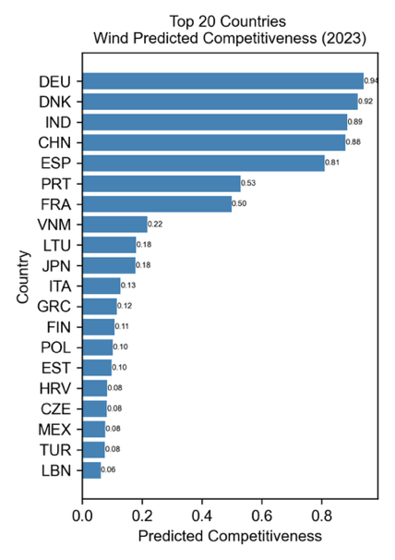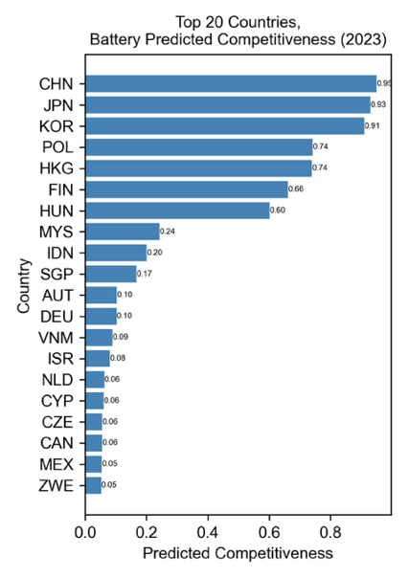
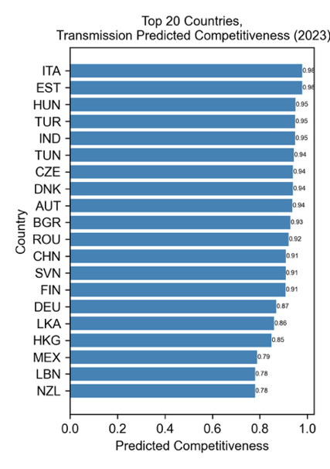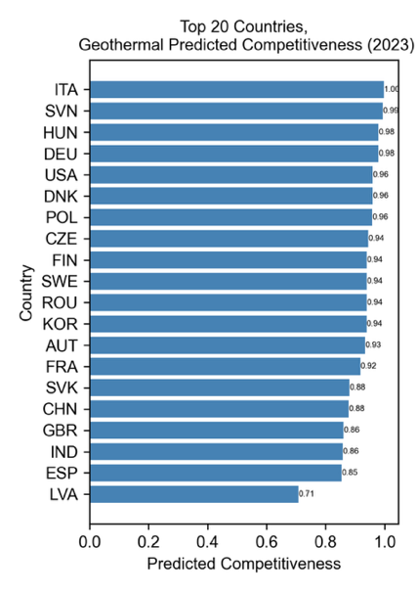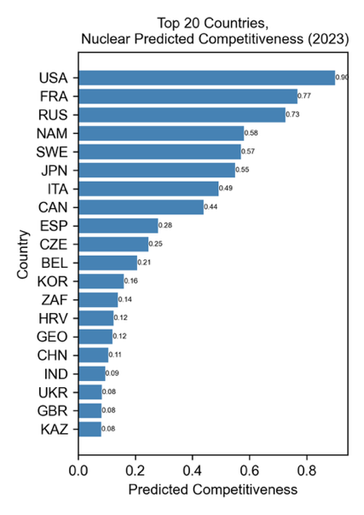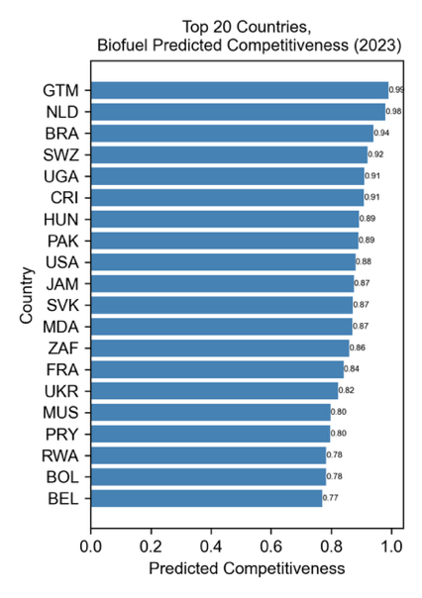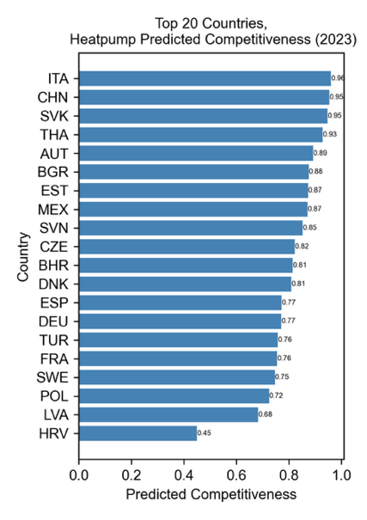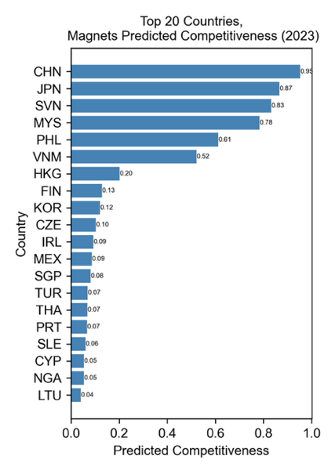

The random forest models exhibit high out of sample classification after tuning via cross-validation, which we report in Extended Data Table 2. In terms of face validity, the models also perform well in that they identify countries that are well-established leaders. For example, in solar, the model identifies China and Southeast Asian states which have received Chinese solar manufacturing foreign direct investment (FDI) as lead exporters. But crucially, the model also ranks countries that do not produce solar panels
Second, the model provides a granular assessment of what drives competitiveness for each technology and country. To do this, we calculate SHAP (SHapley Additive exPlanations) values for all predictors included in our final, trained random forest models. These values identify each predictor's relative importance to country-level predictive competitiveness. We focus on the predictors with the highest SHAP values, standardized using the mean absolute value of z-scores, to identify which variables most strongly shape competitiveness. Our methodology for selecting the most important features and detailed discussion of our SHAP value calculation methodology can be found in the methods section.
These values reveal that each technology has a unique set of capabilities that predict competitiveness. We classified the leading predictors via SHAP values according to where the underlying code falls in the HS code structure. The classification of predictors shows that clean energy industrial capabilities cluster in five areas: electronics, machinery, industrial materials, mining and metals, and chemicals. Electronics contains all forms of electrical apparatus, electronic devices, as well as more advanced technologies like semiconductors and solar cells. Machinery includes components like pumps and cutting machines that feature in both supply chains and production processes. Industrial materials covers wood, stone, glass, gypsum, ceramics, and other materials used in industrial production. Metals spans from extracted minerals through to finished metal products. Chemicals encompasses a range of products from petrochemical byproducts to polymers and catalysts. We sum the values within each of these categories to develop a snapshot of a technology’s industrial base.

Figure 2 provides a visualization of the importance of features for solar (left) and batteries (right) to visualize the differences in the industrial base. This variation is an intuitive but powerful finding. Solar panels are complex electronic and metallic devices attached to industrial glass. Batteries require complex machinery and chemical expertise to perfect metals performance. The model reflects these differences in capabilities.
Figure 2. The industrial base for solar (left) and batteries (right) by product type.
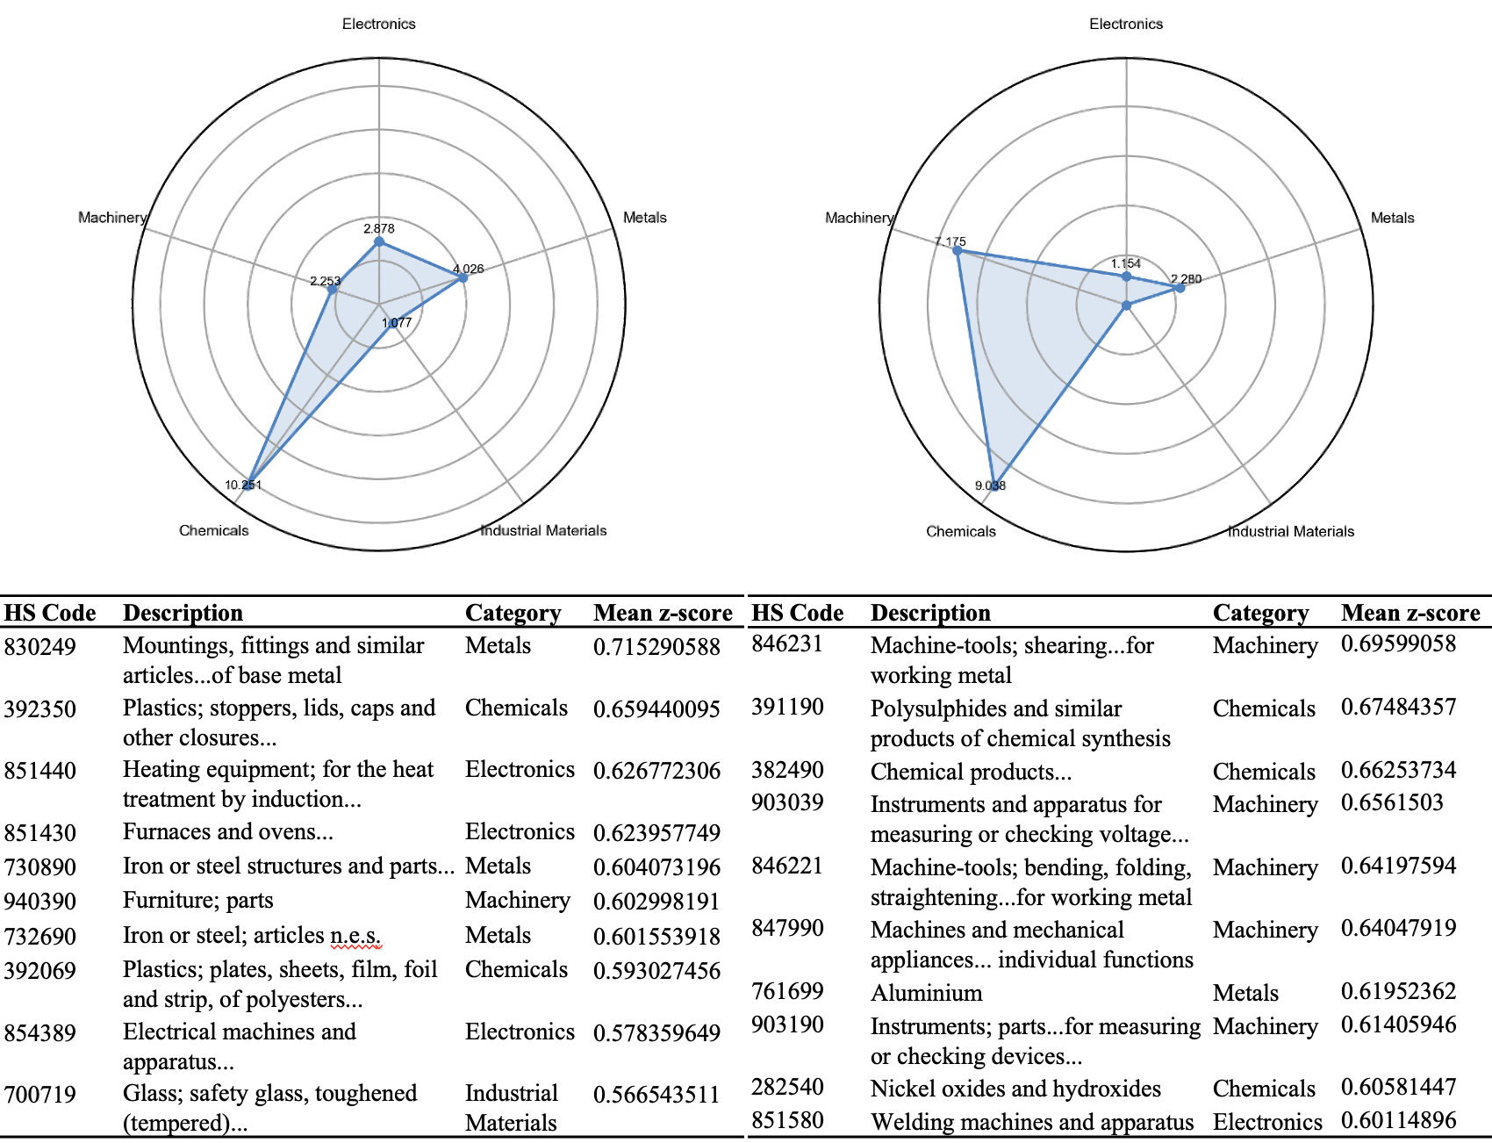
As shown in Supplementary Information Section SI.21-SI.30, the features driving competitiveness in other technologies vary considerably in both magnitude and by technology type, such that each technology has a particular profile. This suggests that strength in the immediate supply and process chain is not a necessary condition for success in each technology. The implication is that competitiveness emerges from something deeper.
The result is a parsimonious mapping of the global industrial base for clean energy that outlines the capabilities needed to be competitive across 10 technologies. With this characterization of the industrial base in hand, the clean industrial capabilities of each country can be mapped in a simple way. We map the country-level industrial base by calculating RCA in the top predictors for the technology and aggregating by capability. Figure 3 provides a radar plot based upon this approach, calculating a composite RCA by predictor category to illustrate the differences in Hungary (left) and Mexico’s (right) industrial base for batteries.
Figure 3. Battery Industrial Base, Hungary (left) versus Mexico (right)
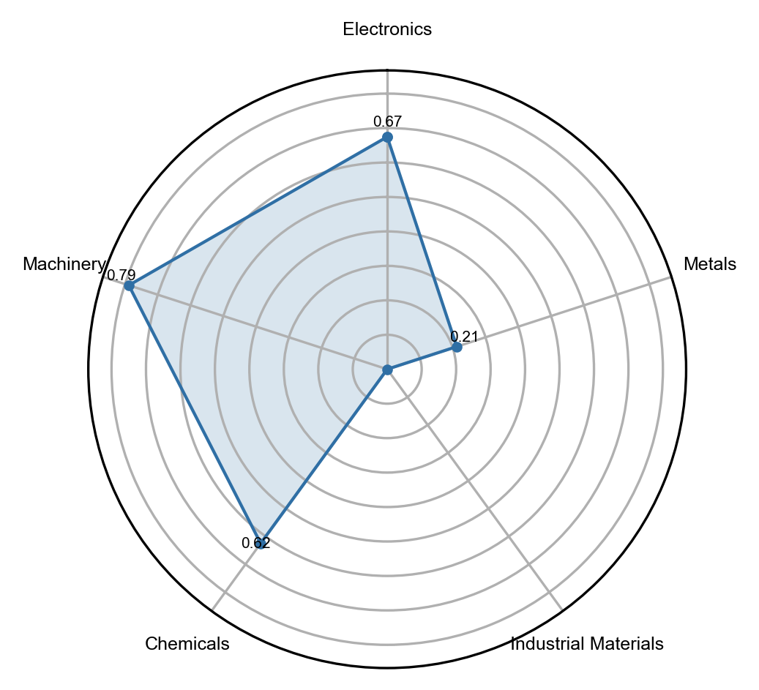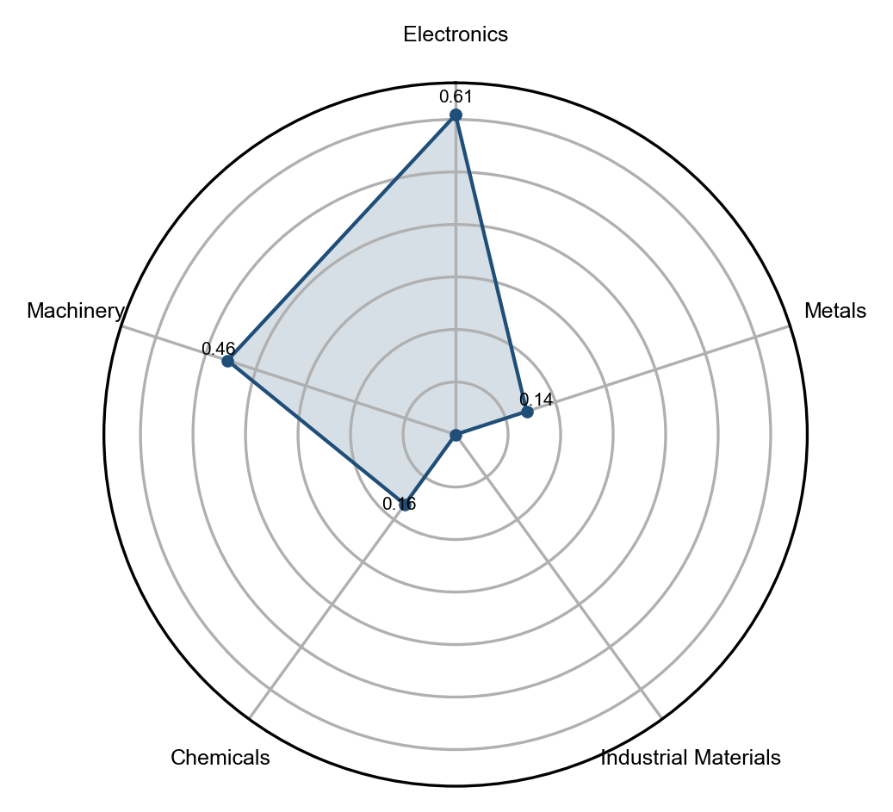
Hungary, one of the most competitive countries in batteries (ranked 7th), has a much stronger industrial base than Mexico, which ranks significantly lower in battery export competitiveness (46th). While Mexico has some capabilities in machinery, it lacks the chemicals expertise that drives battery competitiveness. On the other hand, Hungary’s RCA is much closer to 1 across chemicals, machinery, and electronics. This model gives countries a sense of their current strengths and enables them to map progress over time.

Discussion
The rankings of predicted competitiveness highlight the strength of the world’s industrial giants: China, Japan, Korea, and Germany across a wide range of opportunity areas. The United States has strengths in geothermal, electrolyzers, nuclear, and biofuels, but for its size it lags behind its peers. Denmark, Italy, Spain, and France also emerge as strong competitors alongside a range of smaller European countries. The industrial base for clean energy is highly concentrated in Asia and Europe.
However, many emerging markets and developing economies also demonstrate broad strengths. India scores highly on average, with good competitiveness in solar, wind, magnets, nuclear, and biofuels. This suggests that its recent manufacturing push has been more successful than many realize and that U.S. investments in India may be well-placed to generate long-term supply chain diversification ²². Outside of the top 20, Thailand, Turkey, and Mexico all have strong overall rankings.
However, the point of this model is not to rank overall strengths but allow countries to identify areas of competitive advantage so that they can make smart industrial strategy investments. Consider Figure 4, which summarizes competitiveness across all areas for a number of countries. Here the lesson is not that Malaysia, the top ranked EMDE country, is a powerhouse, but that it has particular strengths in solar, magnets, and transmission.
Figure 4. Technology competitiveness in selected countries, 2023
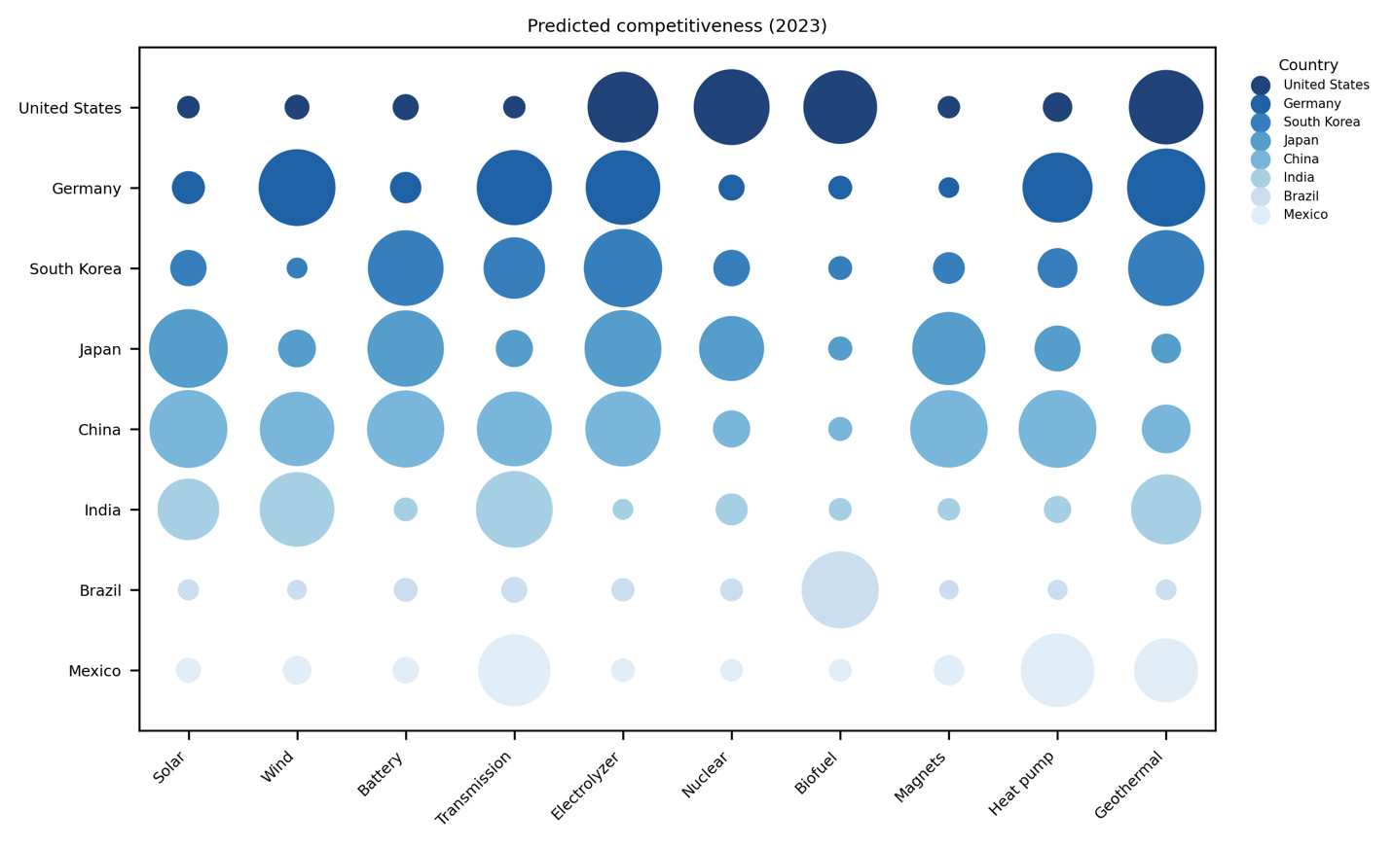
Thailand might easily conclude that it has strengths in electrolyzers and transmission it might like to boost. The model provides tools for doing so. One could easily interpret the results in a mechanical way. For example, to be competitive in electrolyzers, a country could aim to develop zirconium dioxide exports—a top predictor for electrolyzer competitiveness and an important upstream chemical input into electrolyzers. To compete in batteries, a country could build an export sector in flat-rolled steel coated with chromium, the top predictor there. However, this would be applying a false level of precision to the model and misinterpret its implications.
Instead, we can have confidence in the simpler, but more elegant finding that the knowledge and capabilities required to succeed in industrial development differs across technology areas. A comprehensive approach to building these capacities in focused areas is more likely to succeed.
The model is subject to further limitations. The dependent variable is whether or not a country is a competitive exporter of the final product, which does not tell us whether value-added manufacturing is happening in the economy. Re-exports could confound some of the results. We expect this to be a limited problem, but it may help explain the overperformance of some countries. Cross-referencing the results with granular production or value-added data at the country level, not possible in a universal study like this, would be advisable before designing industrial strategy on the results.

Conclusion
The goal of green industrial policy¹⁸ is to secure a country's position in global value chains and support the creation of innovative, competitive ecosystems at home. To do that, countries need to build on their strengths without remaining bound by the status quo.
Our model aims to balance future orientation with a realistic assessment of existing strengths. It helps countries identify sectors in which there are the greatest opportunities for competition. Beyond specific opportunities, it also identifies which parts of the industrial base drive predicted competitiveness. Thus, it can help identify where investments in the industrial base might benefit long-term export capability.
It does this by presenting a simple mapping of the five core capabilities needed to compete in clean energy technologies: electronics, machinery, mining and metals, industrial materials, and chemicals. This finding appears to support new work on industrial policy that suggests that states who invest in core, upstream capabilities are most likely to succeed. In shifting the focus from picking winners to building capabilities, our model reframes green industrial policy as a strategy for building long-term competitiveness rather than making risky market-driven bets.

References

1. Meckling, J. Making Industrial Policy Work for Decarbonization. Global Environmental Politics 21, 134–147 (2021).
2. Allan, B., Lewis, J. I. & Oatley, T. Green Industrial Policy and the Global Transformation of Climate Politics. Global Environmental Politics 21, 1–19 (2021).
3. Allan, B. B. & Nahm, J. Strategies of Green Industrial Policy: How States Position Firms in Global Supply Chains. American Political Science Review 1–15 (2024) doi:10.1017/S0003055424000364.
4. Juhász, R., Lane, N. & Rodrik, D. The New Economics of Industrial Policy. Annual Review of Economics 16, 213–242 (2024).
5. Sabel, C. F. & Victor, D. G. Fixing the Climate: Strategies for an Uncertain World. (Princeton University Press, 2022).
6. Nahm, J. Exploiting the Implementation Gap: Policy Divergence and Industrial Upgrading in China’s Wind and Solar Sectors. The China Quarterly 231, 705–727 (2017).
7. Rodrik, D. Green Industrial Policy. Oxford Review of Economic Policy 30, 469–491 (2014).
8. Williams, R. G. Export Agriculture and the Crisis in Central America. (UNC Press Books, 1986).
9. Nelson, R. R. & Winter, S. G. An Evolutionary Theory of Economic Change. (Harvard University Press, Cambridge, MA, 1982).
10. Kogut, B. & Zander, U. Knowledge of the Firm, Combinative Capabilities, and the Replication of Technology. Organization Science 3, 383–397 (1992).
11. Hidalgo, C. A. & Hausmann, R. The Building Blocks of Economic Complexity. Proceedings of the National Academy of Sciences 106, 10570–10575 (2009).
12. Berger, S. Making in America: From Innovation to Market. (2013).
13. Breznitz, D. Innovation in Real Places: Strategies for Prosperity in an Unforgiving World. (Oxford University Press, Oxford, New York, 2021).
14. Nahm, J. Varieties of Innovation in Wind and Solar Industries. in Collaborative Advantage (Oxford University Press, New York, 2021). doi:10.1093/oso/9780197555361.003.0002.
15. Hidalgo, C. A., Klinger, B., Barabási, A.-L. & Hausmann, R. The Product Space Conditions the Development of Nations. Science 317, 482–487 (2007).
16. Mealy, P. & Teytelboym, A. Economic complexity and the green economy. Research Policy 51, 103948 (2022).
17. Rosenow, S. K. & Mealy, P. Turning Risks into Reward: Diversifying the Global Value Chains of Decarbonization Technologies. https://hdl.handle.net/10986/41024 (2024) doi:10.1596/1813-9450-10696.
18. Amsden, A. H. Asia’s Next Giant: South Korea and Late Industrialization. (Oxford University Press, 1992).
19. Liu, E. Industrial Policies in Production Networks*. Q J Econ 134, 1883–1948 (2019).
20. Lane, N. Manufacturing Revolutions: Industrial Policy and Industrialization in South Korea*. Q J Econ 140, 1683–1741 (2025).
21. Gaulier, G. & Zignago, S. BACI: International Trade Database at the Product-Level. The 1994-2007 Version. Working Papers https://ideas.repec.org//p/cii/cepidt/2010-23.html (2010).
22. United States International Development Finance Corporation. DFC Announces Approval to Provide up to $500 Million of Debt Financing for First Solar’s Vertically-Integrated Thin Film Solar Manufacturing Facility in India | DFC. (2021).

Data availability
The analysis presented in this article is substantiated by data contained in the Supplementary Information. All analysis is based upon public, open access data contained in https://github.com/ishanaratan/CICE-V1.

Code availability
The data and code used in the analysis can be accessed in the GitHub Repository https://github.com/ishanaratan/CICE-V1. Analysis was conducted using Python Version 3.11.5.

Ethics declarations

Authors declare no competing interests.

Extended data figures and tables

Extended Data Table 1. Summary of the number of components for the supply chain and number of proximate products.

Technology | N Supply Chain Products | N Proximate Products
Solar | 46 | 27
Wind | 87 | 39
Batteries | 69 | 20
Biofuels | 63 | 16
Geothermal | 74 | 24
Nuclear | 38 | 6
Electrolyzers | 48 | 23
Heat Pumps | 26 | 4
Permanent Magnets | 17 | 1
Transmission | 25 | 3

Extended Data Table 2. Summary of test set F1 score, precision, recall, and AUC by technology.
Technology | Testing Precision | Testing Recall | Testing F1 Score | AUC
Solar | 0.97 | 0.71 | 0.82 | 0.97
Wind | 0.91 | 0.68 | 0.78 | 0.96
Battery | 0.96 | 0.51 | 0.67 | 0.97
Biofuel | 0.92 | 0.62 | 0.74 | 0.96
Geothermal | 0.95 | 0.83 | 0.89 | 0.98
Nuclear | 0.94 | 0.63 | 0.75 | 0.97
Electrolyzers | 0.85 | 0.52 | 0.65 | 0.92
Heat Pumps | 0.86 | 0.65 | 0.74 | 0.97
Permanent Magnets | 0.98 | 0.80 | 0.88 | 0.98
Transmission | 0.91 | 0.68 | 0.78 | 0.96

Author Information
University of Mississippi, 133 Deupree Hall, Oxford, Mississippi, 38655, United States.
Ishana Ratan

University of Delaware, 405 Smith Hall, 18 Amstel Ave, Newark, Delaware 19716, United States.
Benjamin E. Bagozzi

Johns Hopkins University, 400 N Charles St, Baltimore, Maryland, 21218, United States.
Jonas Goldman, Becky Han, Bentley Allan, Tim Sahay, Bentely Allan

Correspondence and requests for materials should be addressed to Ishana Ratan at iratan@olemiss.edu.

Contributions

Author Contribution Statement: I.R. contributed to data analysis, data visualization, and initial paper, methods, and supplementary information drafting. B.E.B. contributed to the development of the methodology, assisted with the interpretation and visualization of results, contributed to drafting the Methods section, and reviewed and provided feedback on the manuscript and appendix. J.G. and B.H. contributed to data collection. T.S. contributed to paper conceptualization and provided feedback on the main text. B.A. contributed to paper conceptualization, drafting of the main text, and provided feedback on the main text and data analysis and visualization.

We provide descriptive statistics for all technologies’ key predictors in Supplementary Information Section SI.21-30.
Note: In this HS code classification, 84, 86-89, and 90-99 are categorized as machinery; 28-40 as chemicals; 44-49 and 68-70 as industrial materials; 25-27 and 71-83 as metals; and 85 as electronics.
Note: In this HS code classification, 84, 86-89, and 90-99 are categorized as machinery; 28-40 as chemicals; 44-49 and 68-70 as industrial materials; 25-27 and 71-83 as metals; 50-67 as Textiles, and 85 as electronics.

